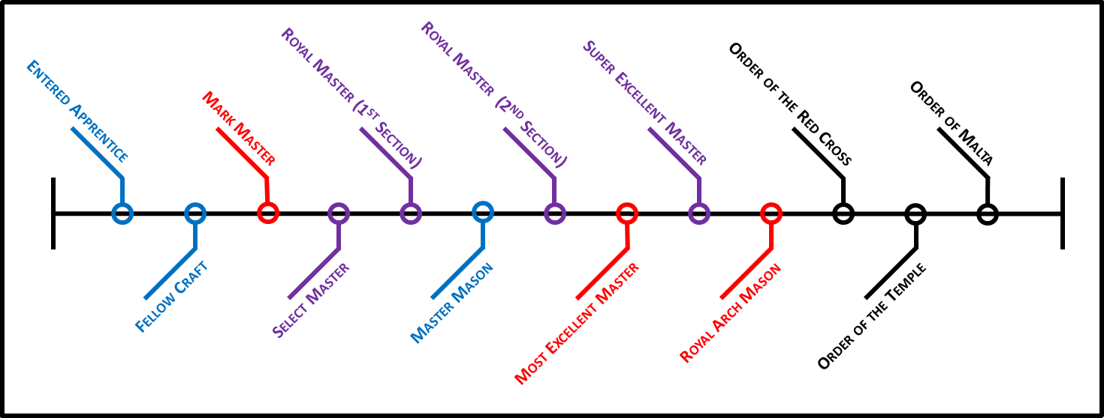

Chapter of Royal Arch Masons
Should a Master Mason choose to seek additional light in Masonry, his travels may lead him to the Chapter of Royal Arch Masons. It is the first step into the York Rite of Freemasonry.

IV Mark Master
The Mark Master degree is the continuation and conclusion of the Fellowcraft degree. Having been invested with the tools and knowledge to work, a Brother must now submit a specimen of his work and seek approval from those appointed to oversee the construction of the Temple. He learns the rewards of hard work, the dangers of dishonesty, and the inherent flaws in following directions to the letter, absent any thought or reasoning. As part of this degree, each Mark Master selects his own mark, to be added to the Lodge Book of Marks. The moral precepts taught in this degree are Honesty and Hard Work as its Own Reward.

V Past Master (Virtual)
In ancient times, the Royal Arch degree could only be conferred upon a Master Mason who had presided over his Lodge as its Master. Nowadays, this degree simulates being installed as Master and each Brother presides for a time over a Lodge of Master Masons, thus fulfilling the requirement for the Royal Arch. The moral precept taught in this degree is Service to the Craft.

VI Most Excellent Master

In this degree, we get to see our labors completed and our work approved by the Highest Authority. After a grand dedication, we realize that our work now being completed, we may, if we choose, enjoy the benefits of being a Master Mason and do some traveling. Or, we may, out of generosity, remain at the Temple in Service to the Craft. The moral precepts taught in this degree are Sacrifice and Piety.

VII Royal Arch Mason

In this Most Sublime degree of Ancient Craft Masonry, the scene shifts from the construction of King Solomon’s Temple to a time after its destruction. Israel has been carried away into captivity in Babylon and then freed. It’s time to build a new Temple. This degree represents the destruction of the First Temple (our physical, mortal temple of clay) and the construction of the Second Temple (our spiritual, imperishable temple of the soul). This degree is the completion of the Master Mason degree, and that which was lost is now found. The moral precept taught in this degree is Holiness to the Lord.

Council of Royal and Select Masters
This optional branch of Ancient Craft Masonry is an offshoot of the Royal Arch degree and is available to all who have received the Royal Arch.

VIII Royal Master
The events of this degree take place before those of the Master Mason and explain in greater detail the need for secrecy and preservation of hidden knowledge. The Companion learns that diligence has its rewards and sometimes one must break a promise for the greater good.

IX Select Master
The events of this degree parallel those in the Mark Master degree. While the Fellowcraft labors above, in the daylight, the Select Masters labor below, in the secrecy of the shadows, to conceal and preserve that which ought not to be lost, and which is found in the Royal Arch degree. It emphasizes that fidelity and secrecy can prevent disaster and that the efforts of one’s labors are never in vain when made for a good cause.

X Super Excellent Master (Honorary)
This is an honorary degree conferred on certain Select Masters. It bridges the time between the first and second temple and is done by a few Bodies in the state.

Commandery of Knights Templar
This body breaks away from the settings and formats of Ancient Craft Masonry and shifts to a historical, chivalrous tone. Sir Knights do not wear the Aprons of a workman, but rather the uniform of a defender of the faith. It is the only branch of the York Rite which requires a candidate to profess a belief in Jesus Christ as the Son of God.

VIII Illustrious Order of the Red Cross
This order is founded upon a border dispute and its resolution and explains the historical background of the Order of Malta.

VIII Mediterranean Pass Degree
This degree is given immediately before the Order of Malta to highlight the trials and tribulations of Saint Paul and chronicle his founding the Knights of Malta.

IX Order of Malta
This is the first of two Christian Chivalric orders conferred upon the Sir Knight. It focuses on the mission, dedication, and history of the Knights of Malta.

X Order of the Temple
This is the crowning glory of the York Rite of Freemasonry. The lessons taught and ritual exemplified therein are striking, bold, and serious. Should one be at all unsure of one’s faith in the divinity of Christ, it is advised that he not take this Order upon himself. It begins the long, perilous journey of a Poor Knight of the Temple of Jerusalem, which is doomed to failure without a faithful reliance on the God of our Salvation.

